ECA5403-ELECTROMAGNETIC FILEDS AND WAVES
NAME: S.S. Manasvini REG NO: 1912260424
C01-2
EXPERIMENT 8
AIM:
To implement the dielectric–free-space boundary conditions for electric fields and determine the relative permittivity of an unknown medium.
Test Case (i)
Normal and Tangential Field Components at the Free-Space / Dielectric Interface Determine the field components, normal flux density and refraction angle in the dielectric for a specified incident field in free space and a specified relative permittivity εr2.
MATLAB Program:
clc; clear;
epsilon0 = 8.854e-12;
E1 = input('Enter magnitude of E1 in free space (V/m): ');
th1 = input('Enter angle of E1 with the normal (deg): ');
er2 = input('Enter relative permittivity of medium 2: ');
E1n = E1*cosd(th1); % normal component in medium 1 E1t = E1*sind(th1); % tangential component in medium 1 D1n = epsilon0*E1n; % normal flux density in medium 1 E2t = E1t; % D2n = D1n; tangential E is continuous % normal D is continuous (rho_s = 0) E2n = D2n/(epsilon0*er2); % normal E in medium 2 E2 = sqrt(E2n^2 + E2t^2);
th2 = atand(E2t/E2n);
fprintf('E1n = %.2f V/m, E1t = %.2f V/m\n', E1n, E1t);
fprintf('D1n = %.4e C/m^2\n', D1n);
fprintf('E2t = %.2f V/m, D2n = %.4e C/m^2\n', E2t, D2n);
fprintf('E2n = %.2f V/m, |E2| = %.2f V/m\n', E2n, E2);
fprintf('Refraction angle theta2 = %.2f deg\n', th2);
figure; plot([0 0],[-80 80],'k','LineWidth',2);
hold on; quiver(-E1n,-E1t,E1n,E1t,0,'b','LineWidth',2); quiver(0,0,E2n,E2t,0,'r','LineWidth',2);
axis equal; grid on; xlabel('Normal direction (V/m)');
ylabel('Tangential direction (V/m)');
title('Electric field at a free-space / dielectric interface');
Sample Output:
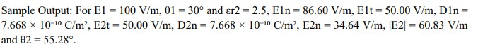
Test Case (ii)
Determination of the Unknown Relative Permittivity from Boundary-Field Data Determine the relative permittivity of the dielectric from the normal electric-field components on the two sides of the interface and calculate the percentage deviation from the reference value.
MATLAB Program:
clc; clear;
E1n = input('Enter normal E-field in free space E1n (V/m): ');
E2n = input('Enter measured normal E-field in the dielectric E2n (V/m): ');
er_ref = input('Enter reference relative permittivity: ');
er_calc = E1n/E2n;
% from D1n = D2n: epsilon0*E1n = epsilon0*er*E2n dev = abs(er_calc - er_ref)/abs(er_ref)*100; fprintf('Calculated relative permittivity = %.4f\n', er_calc);
fprintf('Percentage deviation = %.2f %%\n', dev);
Sample Output:
For E1n = 86.60 V/m, E2n = 34.20 V/m and a reference εr2 = 2.5, the calculated εr2 = 2.532 and the percentage deviation = 1.29 %.
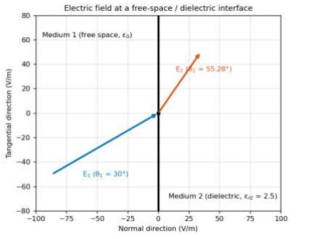

Test Case (iii)
Variation of the Refraction Angle with the Angle of Incidence for Different Dielectrics Simulate the interface for three dielectric constants and plot the angle of the electric field in medium 2 against its angle in medium 1.
MATLAB Program:
clc;
clear;
th1 = linspace(0,89,179);
er = [1.5 2.5 4];
figure; hold on;
for k = 1:3 th2 = atand(er(k)*tand(th1)); % tan(th2) = er2*tan(th1) plot(th1,th2,'LineWidth',2); end plot(th1,th1,'k--'); % er2 = 1 (no dielectric) grid on; xlabel('Angle in medium 1, \theta_1 (deg)');
ylabel('Angle in medium 2, \theta_2 (deg)');
legend('er2 = 1.5','er2 = 2.5','er2 = 4','er2 = 1','Location','southeast');
title('Refraction of the electric field at the interface');
Sample Output:
For θ1 = 30°, θ2 = 40.89° (εr2 = 1.5), 55.28° (εr2 = 2.5) and 66.59° (εr2 = 4); for θ1 = 60° the values are 68.95°, 77.00° and 81.79°.
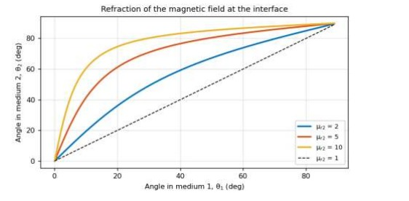
Test Case (iv)
Effect of the Relative Permittivity on the Field Components in the Dielectric Keep the incident field fixed and vary εr2 to show which components are continuous across the boundary.
MATLAB Program:
clc; clear;
epsilon0 = 8.854e-12;
E1 = 100; th1 = 30;
E1n = E1*cosd(th1);
E1t = E1*sind(th1);
er2 = linspace(1,6,100);
E2n = E1n./er2; % normal E in medium 2 E2t = E1t*ones(size(er2)); % tangential E (continuous) E2 = sqrt(E2n.^2 + E2t.^2); D2n = epsilon0*er2.*E2n; % normal D (continuous) subplot(1,2,1);
plot(er2,E2n,er2,E2t,er2,E2,'LineWidth',2); grid on;
xlabel('Relative permittivity er2');
ylabel('Electric field (V/m)');
legend('E2n','E2t','|E2|');
subplot(1,2,2);
plot(er2,D2n,'LineWidth',2);
grid on; ylim([0 1e-9]);
xlabel('Relative permittivity er2');
ylabel('D2n (C/m^2)');
Sample Output:
For E1 = 100 V/m and θ1 = 30°, E2n = 86.60, 34.64, 21.65 and 14.43 V/m and |E2| = 100.00, 60.83, 54.49 and 52.04 V/m at εr2 = 1, 2.5, 4 and 6; E2t stays at 50.00 V/m and D2n stays at 7.668 × 10⁻¹⁰ C/m².
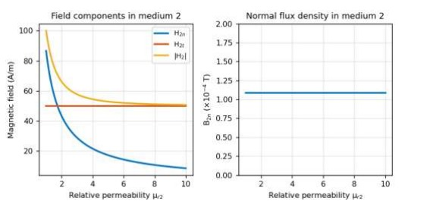
RESULTS:
Thus the Implementation of Dielectric Free-Space Boundary Conditions in Electric Field and Determination of Relative Permittivity using MATLAB software.

S. No. | Objective | Assessment Criterion | Excellent – 4 | Good – 3 | Satisfactory – 2 | Needs Improvement – 1 | Weighting (%) | Marks given | Marks obtained
1 | Define interface and field components | Define interface and field components | Correctly identifies media, normal/ tangential directions and surface-charge assumptions. | Setup is correct with minor omissions. | Needs guidance on components or assumptions. | Interface or component definitions are incorrect. | 25 | 2.5
2 | Apply electric boundary equations | Apply electric boundary equations | Correctly applies continuity of tangential E and the normal D boundary relation. | Applies relations correctly with minor errors. | Partly correct application requires support. | Boundary relations are misapplied. | 25 | 2.5
3 | Determine permittivity and validate | Determine permittivity and validate | Calculates relative permittivity/field components consistently and checks boundary conditions. | Results are mostly correct with minor discrepancies. | Validation is incomplete or contains errors. | Cannot obtain or validate valid results. | 30 | 3
4 | Interpret and document results | Interpret and document results | Explains field behaviour across the interface and reports units/assumptions clearly. | Explanation is correct with minoromissins | Explanation or documentation is incomplete. | Results are not interpreted correctly. | 20 | 2
Total |  |  |  |  |  |  | 100 | 10

